Personal protection
Appearance
Clothing
For general workshop purposes a boiler suit is the most practical and safest form of clothing. However, to be completely effective certain precautions must be taken as shown in Fig. 1.
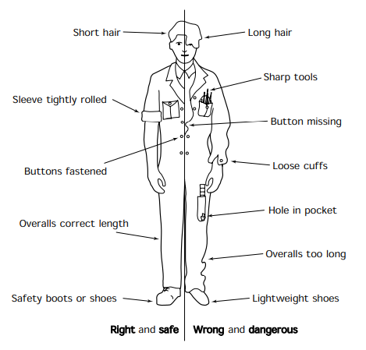
Figure 1.Correct and incorrect dress

Long hair

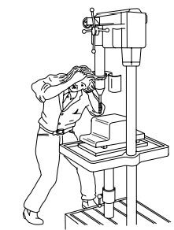
• Long hair is liable to be caught in moving machinery such as drilling machines and lathes. This can result in the hair and scalp being torn away which is extremely dangerous and painful. Permanent disfigurement will result and brain damage can also occur.
• Long hair is also a health hazard, as it is almost impossible to keep clean and free from infection in a workshop environment. Either adopt a short and more manageable head style or some sort of head covering that will keep your hair out of harm’s way.
Sharp tools
Sharp tools protruding from the breast pocket can cause severe wounds to the wrist. Such wounds can result in paralysis of the hand and fingers.
Buttons missing and loose cuffs
Since the overalls cannot be fastened properly, it becomes as dangerous as any other loose clothing and is liable to be caught in moving machinery. Loose cuffs are also liable to be caught up like any other loose clothing. They may also prevent you from snatching your hand away from a dangerous situation.
Hole in pocket
Tools placed in a torn pocket can fall through onto the feet of the wearer. Although this may not seem potentially dangerous, it could cause an accident by distracting your attention at a crucial moment.
Overalls too long
These can cause you to trip and fall, particularly when negotiating stairways.
Lightweight shoes
The possible injuries associated with lightweight and unsuitable shoes are:
• puncture wounds caused by treading on sharp objects;
• crushed toes caused by falling objects;
• damage to your Achilles tendon due to insufficient protection around the heel and ankle.

Head and eye protection
As has already been stated, long hair is a serious hazard in a workshop. If it becomes entangled in a machine, the operator can be scalped. If you wish to retain a long hairstyle in the interests of fashion, then your hair must be contained in a close fitting cap. This also helps to keep your hair and scalp clean and healthy.
When working on site, or in a heavy engineering erection shop involving the use of overhead cranes, all persons should wear a safety helmet complying with BS 2826. Even small objects such as nuts and bolts can cause serious head injuries when dropped from a height. Figure 2(a) shows such a helmet. Safety helmets are made from high impact resistant plastics or from fibre-glass reinforced polyester mouldings. Such helmets can be colour coded for personnel identification and are light and comfortable to wear. Despite their lightweight construction, they have a high resistance to impact and penetration. To eliminate the possibility of electric shock, safety helmets have no metal parts. The harness inside a safety helmet should be adjusted so as to provide ventilation and a fixed safety clearance between the outer shell of the helmet and the wearer’s skull. This clearance must be maintained at 32 millimetres. The entire harness is removable for regular cleaning and sterilizing. It is fully adjustable for size, fit and angle to suit the individual wearer’s head.
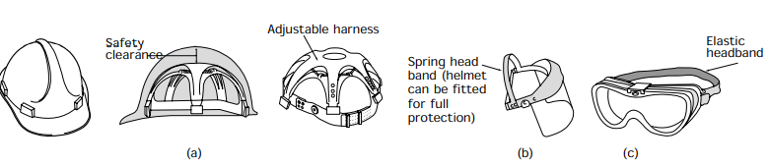
Figure 2. Head and eye protection: (a) a typical fibre-glass safety helmet made to BS 2826; (b) plastic face safety visor for complete protection against chemical and salt-bath splashes; (c) transparent plastic goggles suitable for machining operations

Whilst it is possible to walk about on an artificial leg, nobody has ever seen out of a glass eye. Therefore eye protection is possibly the most important precaution you can take in a workshop. Eye protection is provided by wearing suitable visors as shown in Fig. 2(b) or goggles as shown in Fig. 2(c).
Eye injuries fall into three main categories:
• Pain and inflammation due to abrasive grit and dust getting between the lid and the eye.
• Damage due to exposure to ultraviolet radiation (arc-welding) and high intensity visible light. Particular care is required when using laser equipment.
• Loss of sight due to the eyeball being pierced or the optic nerve being cut by flying splinters of metal (swarf), or by the blast of a compressed air jet.
Where eye safety is concerned, prevention is better than cure. There may be no cure!
Hand protection
Your hands are in constant use and, because of this, they are constantly at risk handling dirty, oily, greasy, rough, sharp, hot and possibly corrosive and toxic materials. Gloves and ‘palms’ of a variety of styles and types of materials are available to protect your hands whatever the nature of the work. Some examples are shown in Fig. 3. In general terms, plastic gloves are impervious to liquids and should be worn when handling oils, greases and chemicals. However, they are unsuitable and even dangerous for handling hot materials. Leather gloves should be used when handling sharp, rough and hot materials. NEVER handle hot workpieces and materials with plastic gloves. These could melt onto and into your flesh causing serious burns that would be difficult to treat.
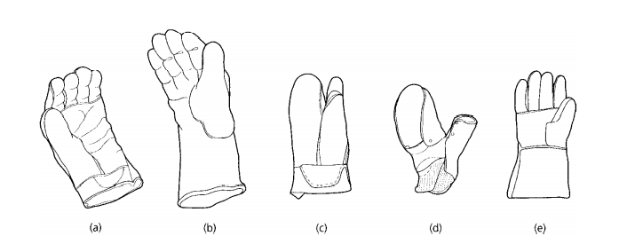
Figure 3. Gloves suitable for industrial purposes: (a) leather glove with reinforced palm – ideal for handling steel sheet and sections; (b) gauntlet – available in rubber, neoprene or PVC for handling chemical, corrosive or oily materials; (c) heat resistant leather glove – can be used for handling objects heated up to 360◦ C; (d) chrome leather hand-pad or ‘palm’ – very useful for handling sheet steel, sheet glass, etc.; (e) industrial gauntlets – usually made of leather because of its heat resistance; gauntlets not only protect the hands but also the wrists and forearms from splashes from molten salts and hot quenching media
Where gloves are inappropriate, as when working precision machines, but your hands still need to be protected from oil and dirt rather than from cuts and abrasions, then you should use a barrier cream. This is a mildly antiseptic cream that you can rub well into your hands before work. It fills the pores of your skin and prevents the entry of oils and dirt that could cause infection. The cream is water-soluble and can be removed by washing your hands with ordinary soap and water at the end of the shift. Removal of the cream carries away the dirt and sources of infection.
DO NOT use solvents to clean your hands except under medical supervision. As well as removing oils, greases, paints and adhesives, solvents also remove the natural protective oils from your skin. This leaves the skin open to infection and can lead to cracking and sores. It can also result in sensitization of the skin and the onset of industrial dermatitis.
Foot protection
The dangers associated with wearing unsuitable shoes in a workshop have already been discussed. The injuries that you can suffer when wearing lightweight, casual shoes are shown in Fig. 4. This figure also shows some examples of safety footwear as specified in BS 1870. Such safety footwear is available in a variety of styles and prices. It looks as smart as normal footwear and is almost as comfortable.

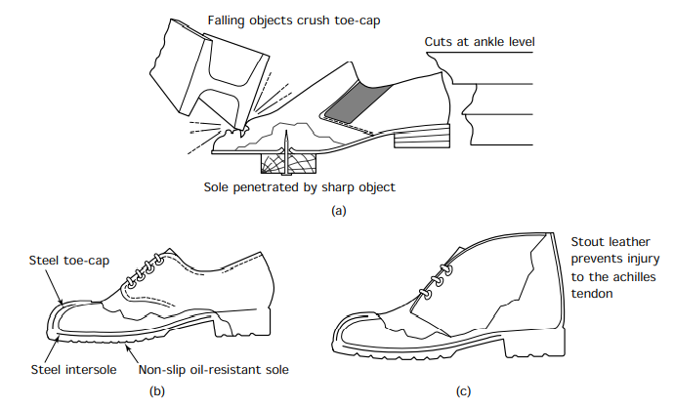
Figure 4. Safety footwear: (a) lightweight shoes offer no protection; (b) industrial safety shoe; (c) industrial safety boot oils, greases and chemicals. However, they are unsuitable and even dangerous for handling hot materials. Leather gloves should be used when handling sharp, rough and hot materials. NEVER handle hot workpieces and materials with plastic gloves. These could melt onto and into your flesh causing serious burns that would be difficult to treat.

Task 1 Complete the sentences using Fig.1
Model: It is dangerous / safe (long hair) – It is dangerous to wear long hair.
- It is dangerous / safe (short hair)
- It is dangerous / safe (sharp tools)
- It is dangerous / safe (buttons missing)
- It is dangerous / safe (buttons fastened)
- It is dangerous / safe (loose cuffs)
- It is dangerous / safe (sleeves tightly rolled)
- It is dangerous / safe (have hole in a pocket)
- It is dangerous / safe (lightweight shoes)
- It is dangerous / safe (safety boots)
- It is dangerous / safe (long overalls)

Task 2 Fill in the table:

Clothing/equipment | Situation/environment
- Close fitting cap | If you wish to retain a long hairstyle in the interests of fashion
- Overalls
- Leather gloves
- PVC/rubber gloves
- Safety helmet
- Clear goggles
- Visor
- Barrier cream
- Safety boots
- Goggles with filter lenses
- Gauntlets

(From Engineering Fundamentals)

